**D.Y. PATIL COLLEGE OF ENGINEERING &TECHNOLOGY,**

**KASABA BAWADA, KOLHAPUR**

DEPARTMENT OF COMPUTER SCIENCE & ENGINEERING

(Academic Year: 2023-24)



**PROJECT-1 SYNOPSIS**

**ON**

**FILE CONVERTER**

|  |  |  |
| --- | --- | --- |
| **Sr.no** | **Name** | **Roll No** |
| 1. | Atharv Pravin Babar | 10 |
| 2. | Saurabh Shrikant Lohar | 11 |
| 3. | Alfaj Mansur Mahabri | 14 |

Submitted By

Under the guidance of

Mrs. Swati Ambi

Class: SY (CSE) Div: A Batch: S-1

**INDEX**

|  |  |  |
| --- | --- | --- |
| **Sr No** | **Title** | **Page** |
| 1 | Introduction | 2 |
| 2 | Problem Statement | 3 |
| 3 | Objective | 4 |
| 4 | System Architecture | 5 |
| 5 | Modules | 7 |
| 6 | System Requirement | 8 |
| 7 | Reference | 9 |

1. **INTRODUCTION**

The File Converter project is a comprehensive software application developed using C++ that combines the power of OpenCV and file handling to facilitate the seamless conversion of images between the JPG, PNG, and WEBP formats. This project incorporates a user-friendly Graphical User Interface (GUI) to enhance accessibility and ease of use.

The key functionalities of the File Converter include the ability to handle various image file formats, providing users with a versatile platform for converting images according to their preferences. The integration of OpenCV allows for efficient image processing, ensuring high-quality conversions while maintaining optimal performance.

The project employs file handling mechanisms to manage input and output operations, ensuring the smooth flow of data during the conversion process. Users can navigate through the intuitive GUI to select input files, specify desired output formats, and initiate the conversion with just a few clicks.

By combining the robust capabilities of C++, OpenCV, and file handling, the File Converter project addresses the growing need for a flexible and efficient tool to convert images across different formats. This software serves as a valuable resource for users seeking a reliable solution for managing their image files, offering a seamless and streamlined experience for image conversion tasks.

1. **PROBLEM STATEMENT**

The File Converter project aims to create a user-friendly, cross-platform solution using C++ and OpenCV for efficient conversion between image formats like JPG, PNG, and WEBP. It addresses issues such as complex interfaces, quality degradation, platform dependence, and inefficient file handling in existing tools.

1. **OBJECTIVE**

**1. Format Flexibility:**

Enable users to convert image files between JPG, PNG, and WEBP formats, accommodating the diverse needs of digital media users.

**2. User-Friendly Interface:**

Design an intuitive Graphical User Interface (GUI) to enhance user accessibility, allowing individuals with varying levels of technical expertise to navigate and utilize the conversion functionalities effortlessly.

**3. Image Quality Preservation:**

Implement advanced image processing techniques using OpenCV to ensure the preservation of image quality during the conversion process, maintaining clarity and detail.

**4. Efficient File Handling:**

Incorporate efficient file handling mechanisms to manage input and output operations, ensuring a smooth and error-free flow of data throughout the conversion process.

**5. Cross-Platform Compatibility:**

Develop the File Converter as a cross-platform application, ensuring compatibility with different operating systems, thereby increasing its accessibility and usability.

1. **SYSTEM ARCHITECTURE**

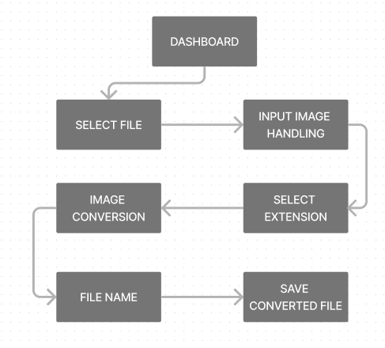fig. System Architecture

1. **Dashboard:**

This is the starting point of the application where users interact with the software. It provides a user-friendly interface for easy navigation.

1. **Select File:**

In this step, users choose the image file they wish to convert. The software supports various image file formats, providing a versatile platform for users.

1. **Input Image Handling:**

Once the file is selected, the system handles and processes the selected image file, preparing it for conversion. This involves reading the file into the system and validating its format.

1. **Image Conversion:**

This is the core step where the actual conversion of the image happens. The software uses OpenCV for efficient image processing, ensuring high-quality conversions while maintaining optimal performance.

1. **File Name:**

After the conversion, users have an option to name or rename the converted file. This allows users to organize their files according to their preferences.

1. **Select Extension:**

In this step, users specify the desired output format (JPG, PNG, WEBP). This gives users the flexibility to choose the format that best suits their needs.

1. **Save Converted File:**

Finally, the converted file is saved as per user specifications. The file handling mechanisms manage input and output operations, ensuring the smooth flow of data during the conversion process.

1. **MODULES**

**1. User Interface (UI) Module:**

Serves as the interactive gateway for users, offering features such as a file selection dialog, output format selection, and controls to initiate conversions. It also includes elements for progress tracking and status display, ensuring a seamless and user-friendly experience.

**2. File Handling Module:**

The focus lies on efficient management of input and output files. This involves reading input files, writing output files, and implementing robust error handling and reporting mechanisms. By streamlining these processes, the module contributes to the overall reliability of the File Converter.

**3. Image Conversion Module:**

Using OpenCV functions, it facilitates the transformation between different image formats while employing techniques to preserve image quality. This module is designed to handle diverse image resolutions and aspect ratios, ensuring a versatile and high-quality conversion experience.

**4. Format Detection Module:**

This module identifies the input image format, validates its compatibility for conversion, and provides feedback to the user on the detected formats. It ensures a smooth and transparent conversion process by keeping the user informed.

1. **SYSTEM REQUIREMENT**

**A. Hardware Requirement**

1. **Processor:**
   * Multi-core processor with sufficient processing power
2. **RAM:**
   * Minimum 1 GB.

**B. Software Requirement**

1. **Operating System:**
   1. Windows, macOS, or Linux.
2. **Dependencies:**
   1. OpenCV library.
3. **Software:**
   1. Compatible C++ development environment.

**REFERNECE**

1. <https://docs.opencv.org/4.x/d9/df8/tutorial_root.html>
2. <https://github.com/GeorgeSeif/Image-Processing-OpenCV>
3. <https://github.com/jayrambhia/Install-OpenCV>